Digital Signal Generation and Reading using dSPACE

1. Configuration Desk Setup

1.1. Create a new project in Configuration Desk
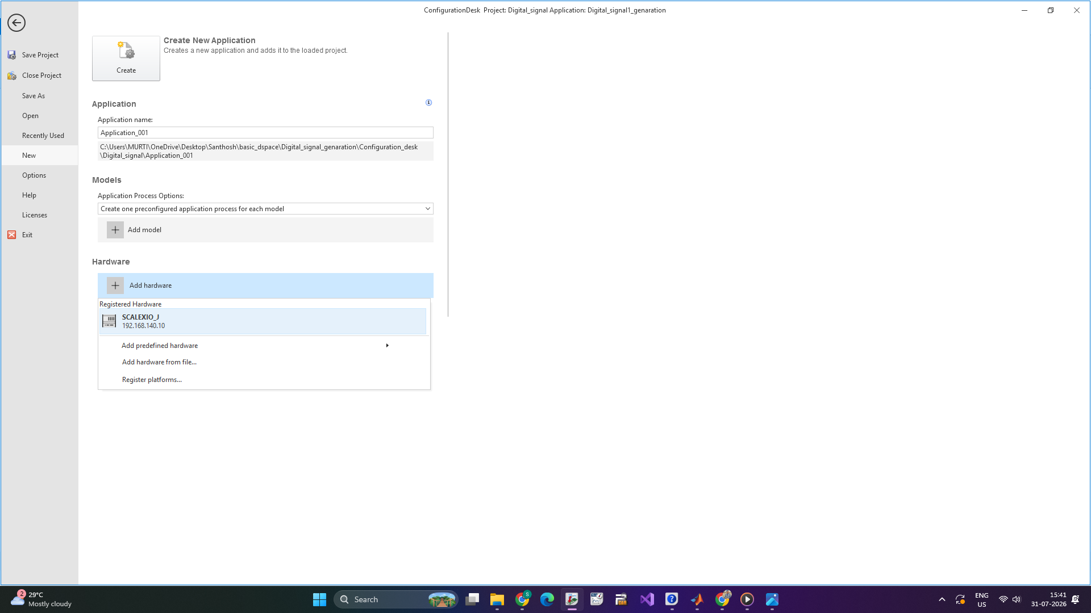

1.2. Add the hardware (e.g., SCALEXIO Rack) by importing it in the 'Model - function and Hardware resources' section.
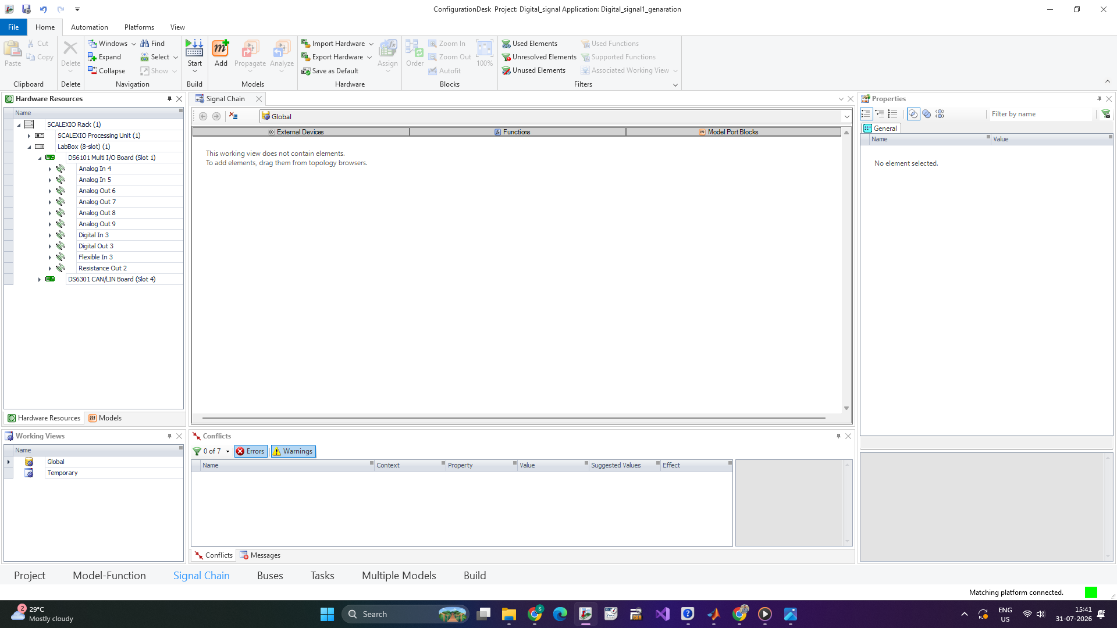

2. Digital Signal Generation

2.1. In the 'Signal Chain and Hardware Resources' section, drag and drop the function block for the DS6101 Multi-I/O Board (a 3-slot SCALEXIO I/O board).
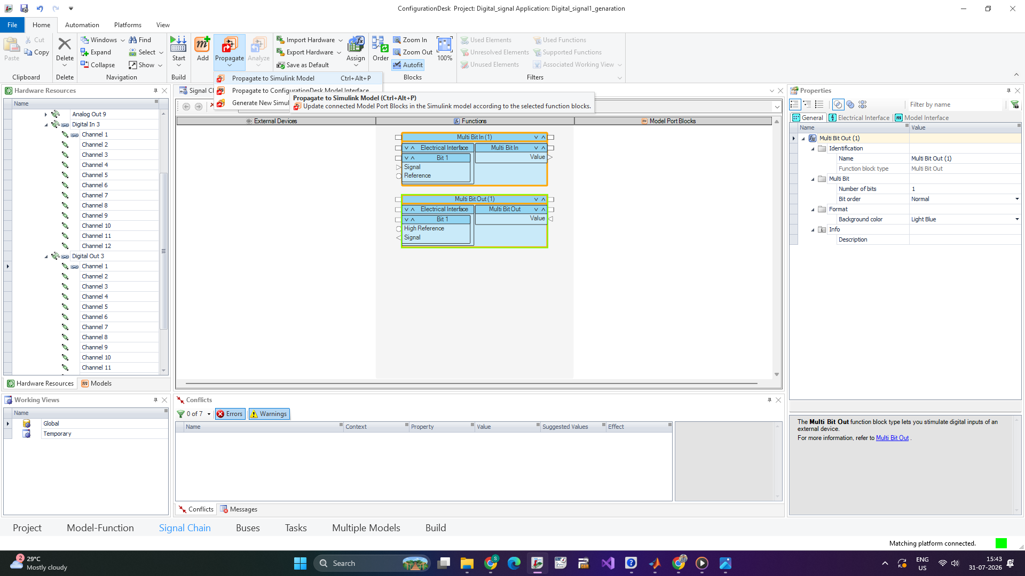

2.2. Select a 'Digital Out' channel (e.g., Digital Out 3) depending on the voltage range required for the output.

2.3. Set the digital out as high-side switch.
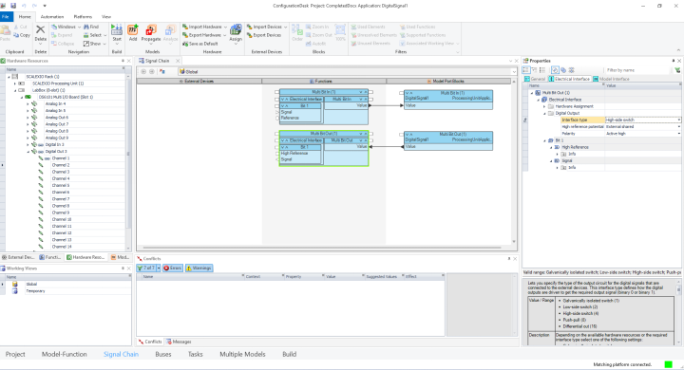

2.4. This output will generate voltage signals from the ECU or dSPACE system.

3. Digital Signal Reading

3.1. In the 'Signal Chain and Hardware Resources', drag and drop a function block for 'Digital In' channels (e.g., Digital In 3 or any channel).

3.2. Set the voltage threshold for reading input voltage from the ECU or dSPACE system. The signal will turn ON if the input voltage exceeds the threshold voltage.
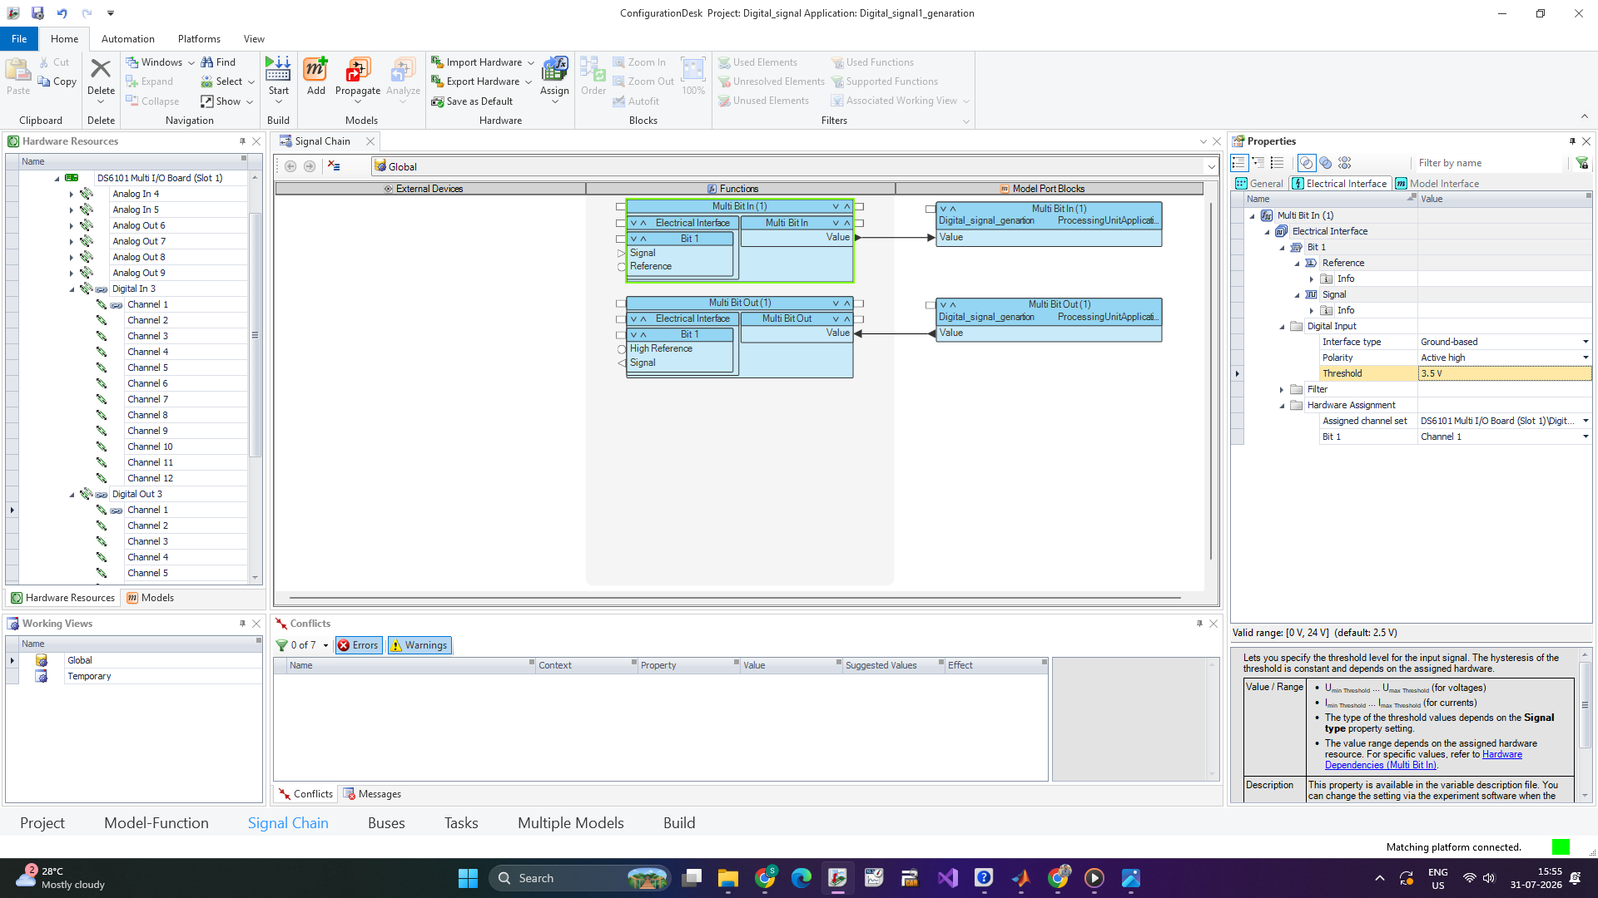

4. Simulink Model Setup

4.1. Enable 'Test Automation Support' and 'Behavior Model' for the function blocks you want to control.

4.2. Propagate the Simulink model and save it. Import this model into the signal chain.

4.3. After connecting the model pins and setting up the signal chain, build the project.
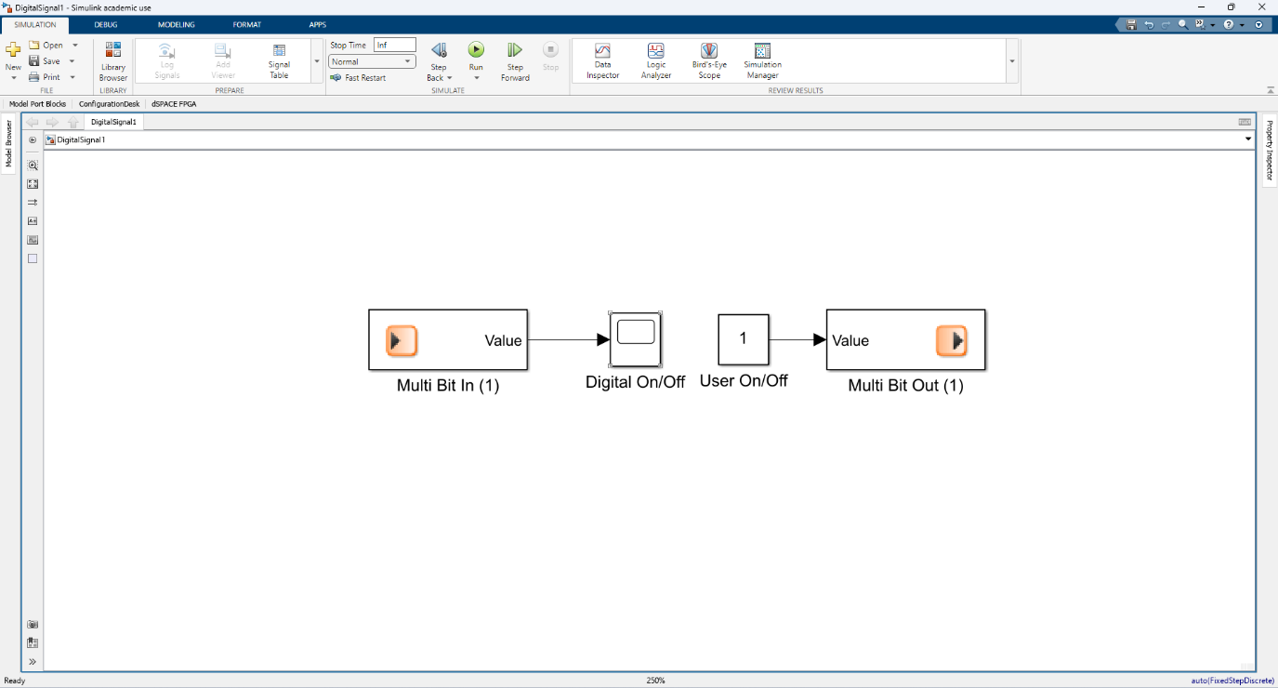
And then you will see the top ribbon build the project onces its complete with all the issues it look like this
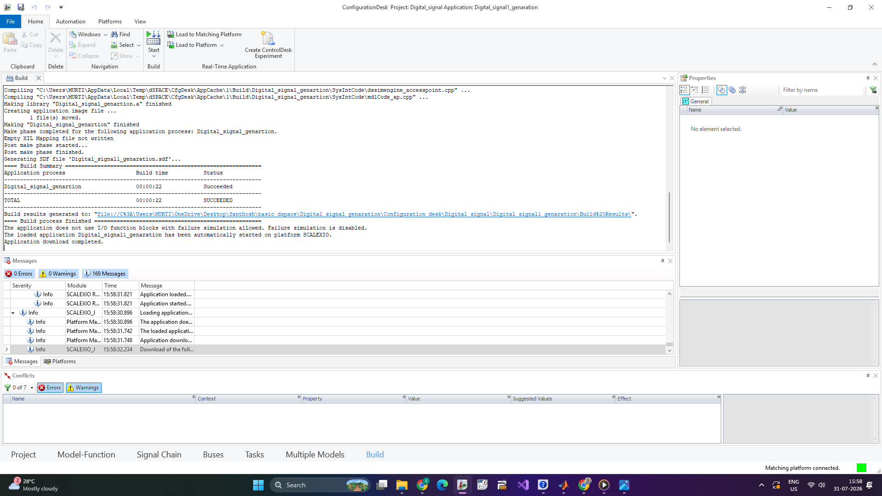

5. Control Desk Setup

5.1. Create a new project in Control Desk select the hardware configuration created earlier.
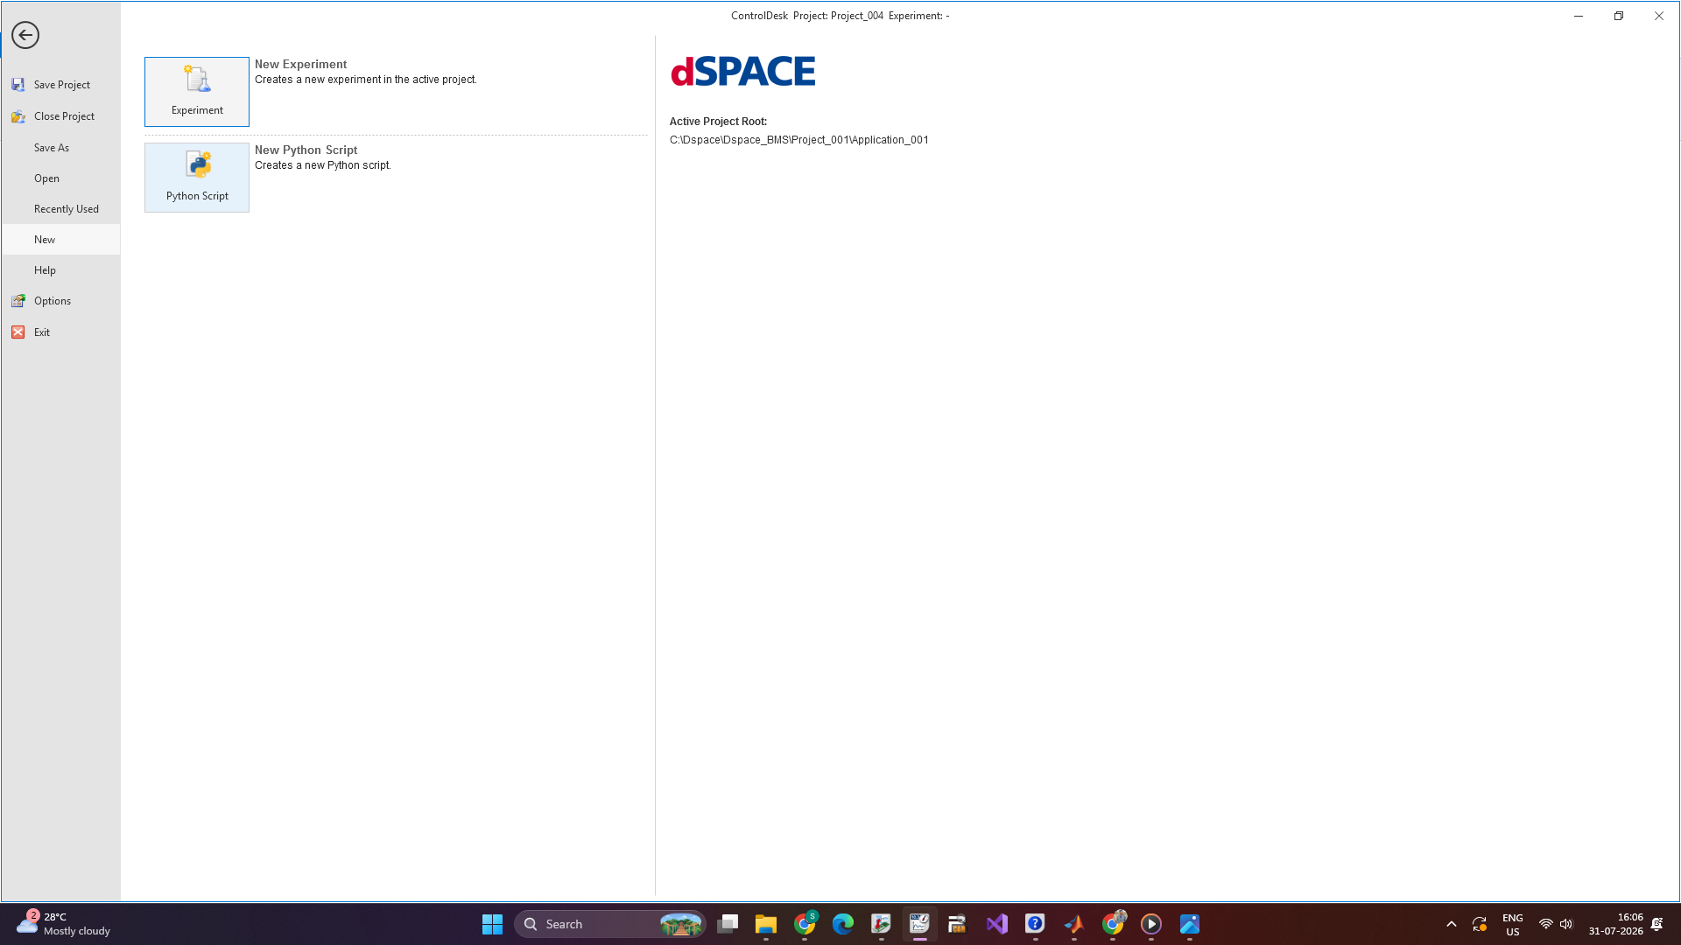

5.2. Access the model variables and set up your desired layout in the Control Desk for visualization.
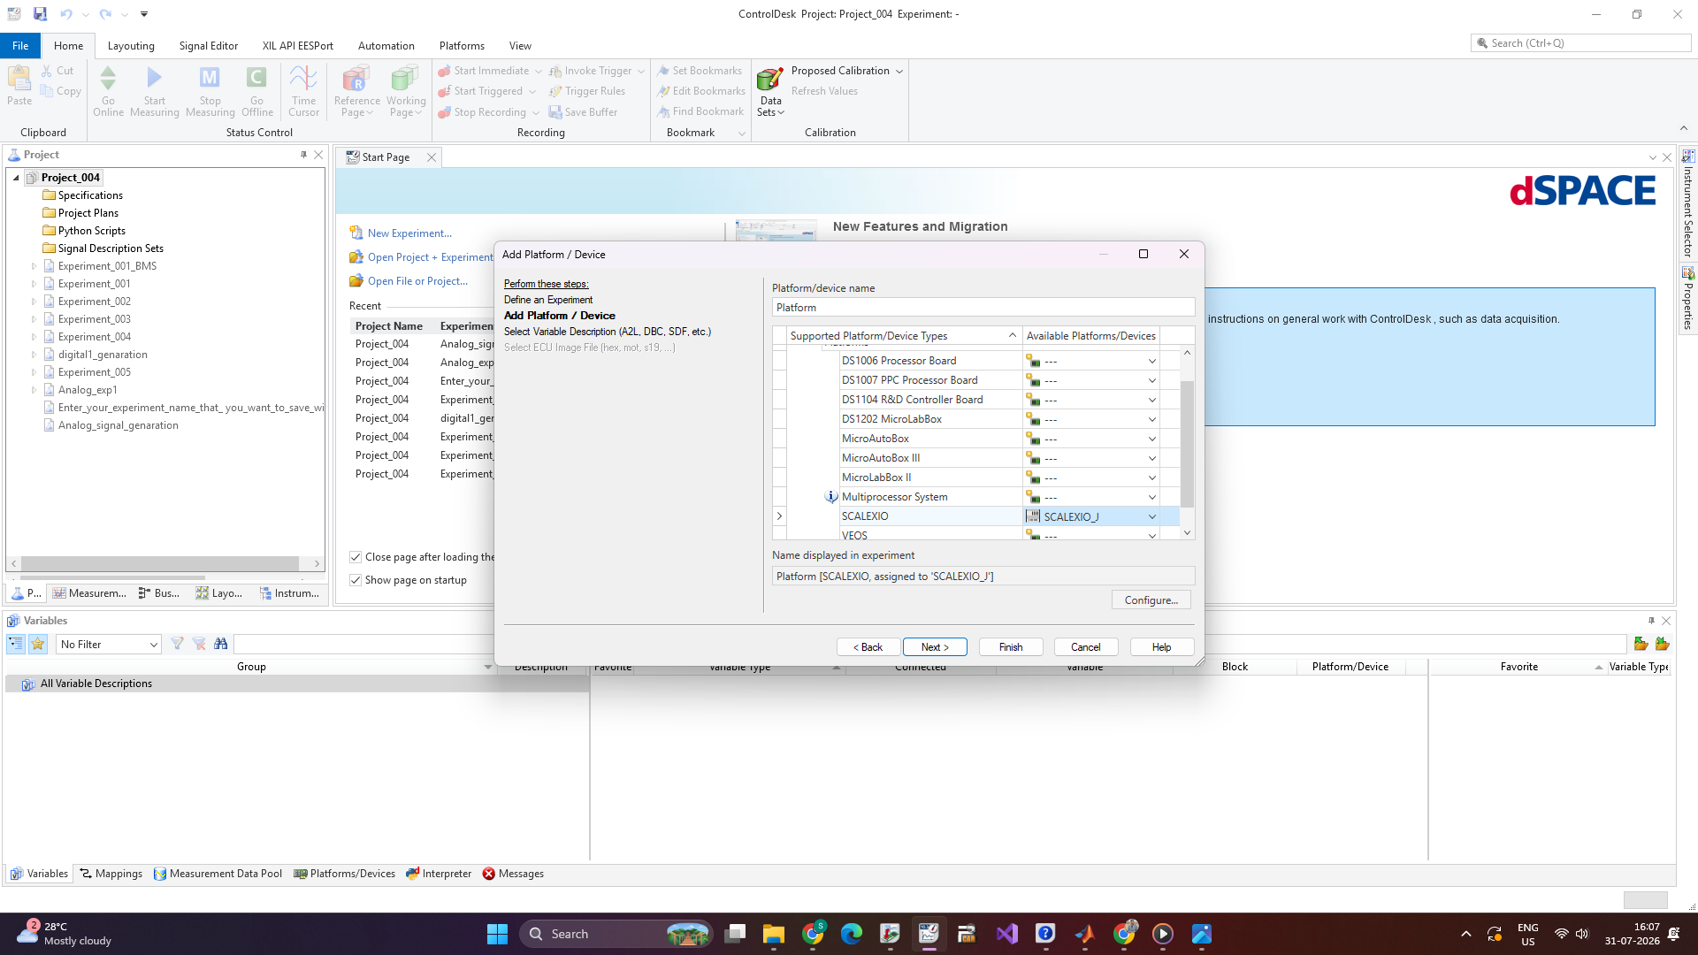
Then select the simulink description file that generated from the configuration desk
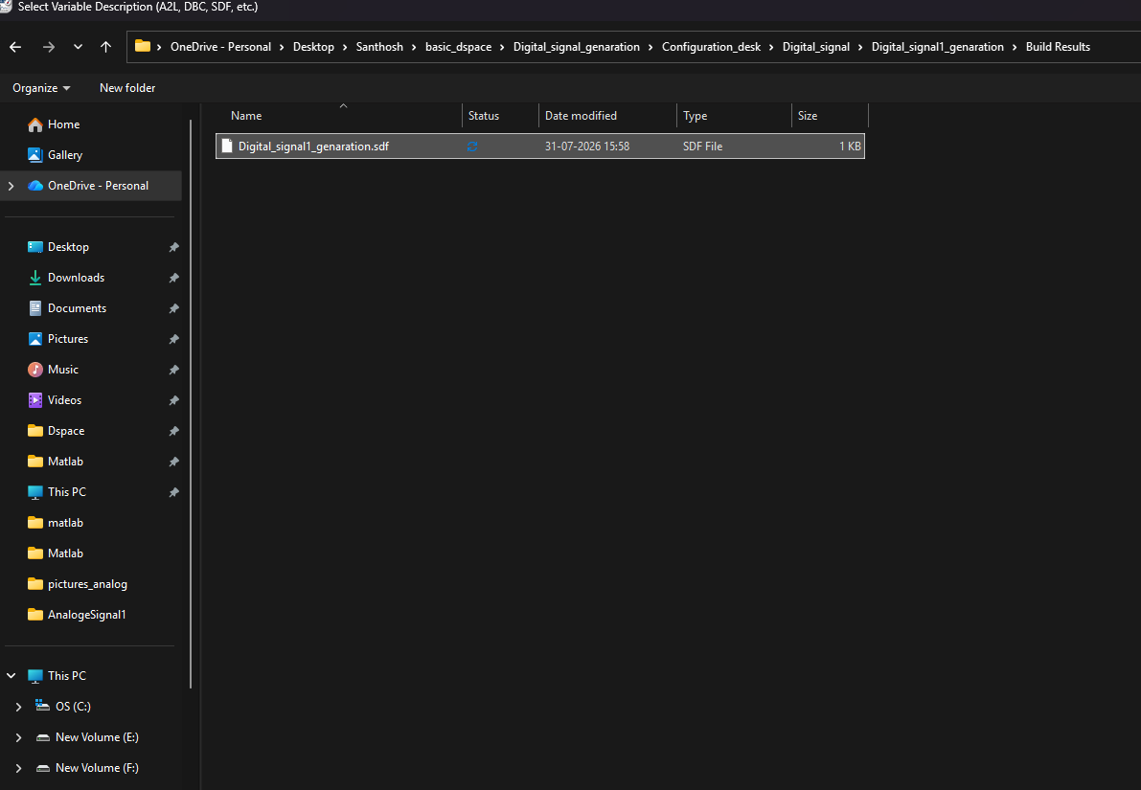
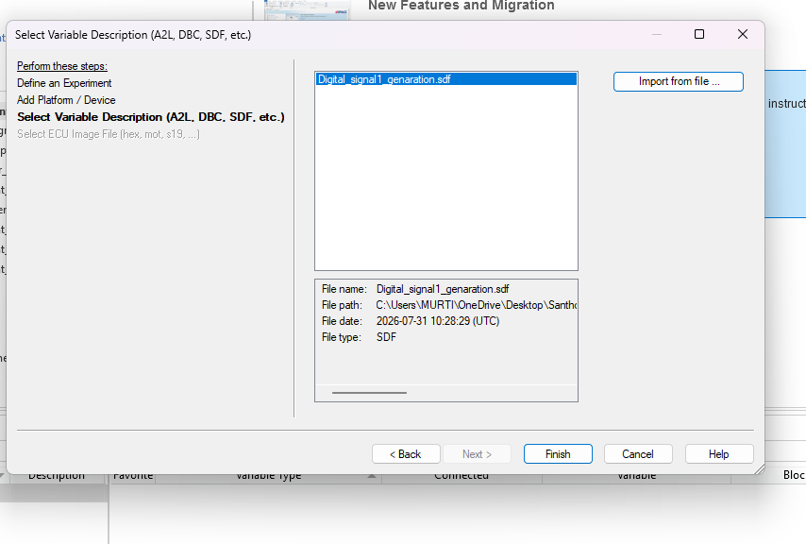
Then click the finish button and see our project was loaded in to the control desk environment
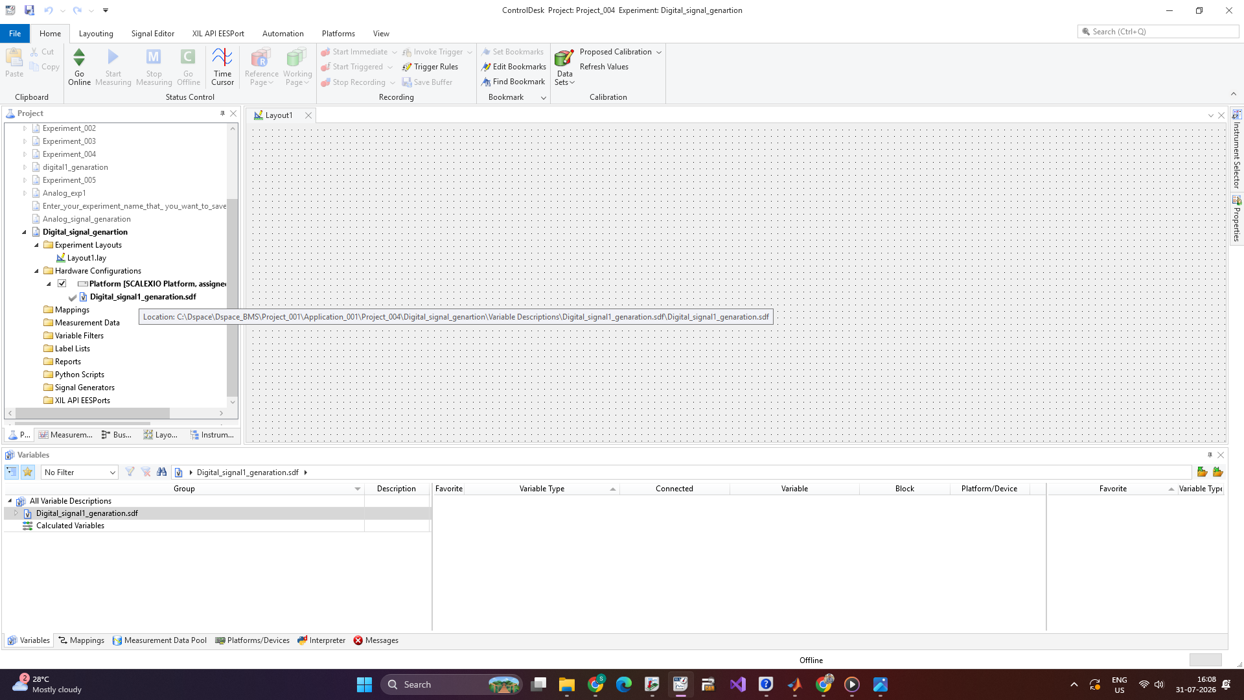

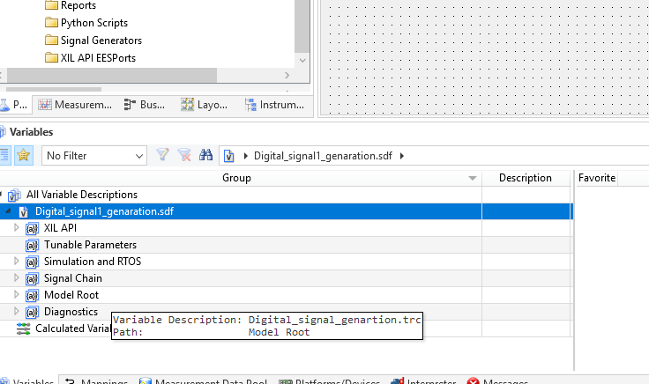
Go through the Variables section and under the model root you can see the variables of simulink file that we use to control and observ the things please drag and drop the variables we want as shown in the figure.
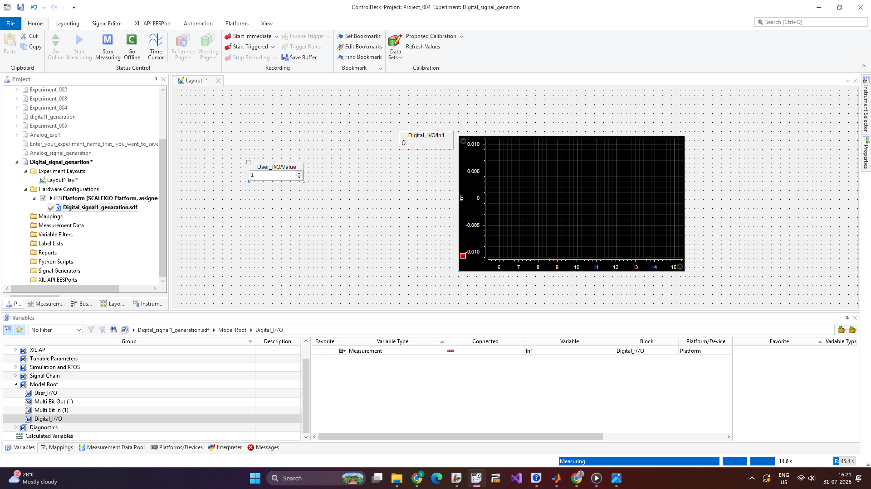

6. Hardware Connection

6.1. Make connections like looping the signal and ground wires between specific pin numbers:.
- SUBD1/26 to SUBD1/18 for signal connection
· SUBD1/34 to +VB (external battery) and SUBD1/1 to -VB for ground connection.
· Ensure the digital signal has a common ground.
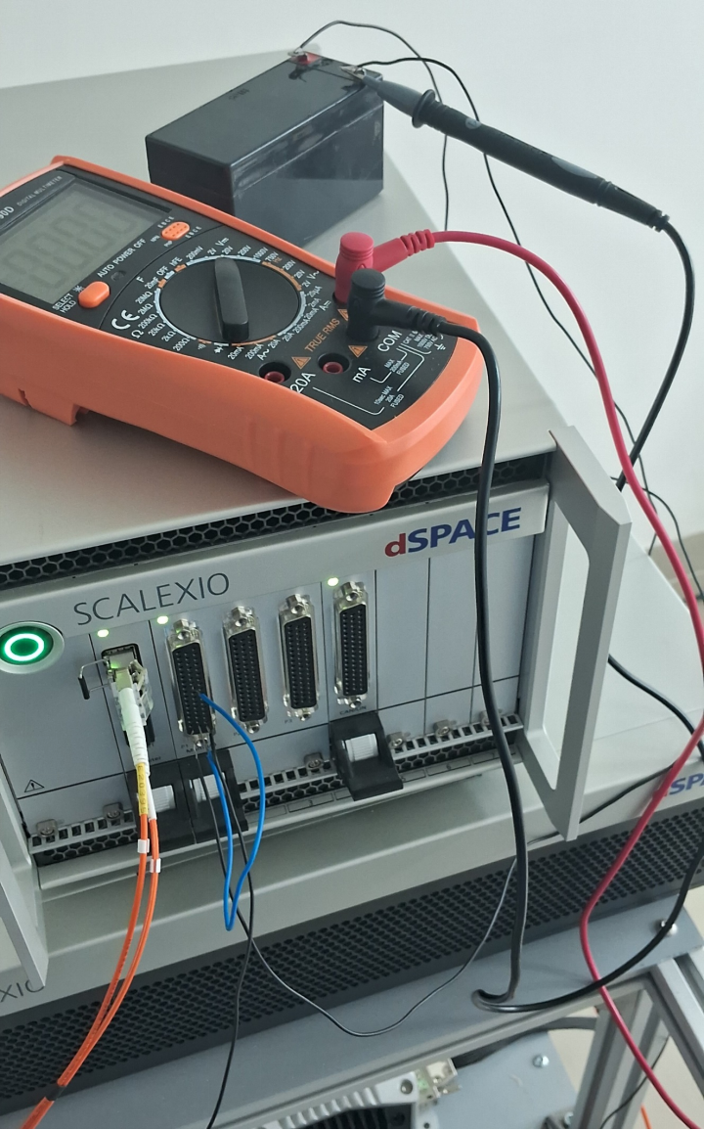

Result:


